Catalytic site
The part of the enzyme where the substrate binds is called the active site or catalytic site since that’s where the catalytic “action” happens.

Enzyme substrate interaction
Lock-and-key mechanism A mechanism proposed in 1890 by Emil Fischer. The active site was thought to have a fixed structure (the lock), which exactly matched the structure of a specific substrate (the key). Thus the enzyme and substrate interact to form an enzyme–substrate complex.
Induced fit model takes into account the fact that proteins have some three-dimensional flexibility. The binding of the substrate induces a conformational change in the enzyme that results in a complementary fit once the substrate is bound.

Working of enzyme

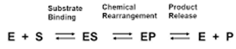
Enzymes perform the critical task of lowering a reaction's activation energy—that is, the amount of energy that must be put in for the reaction to begin. Enzymes work by binding to reactant molecules and holding them in such a way that the chemical bond-breaking and bond-forming processes take place more readily.

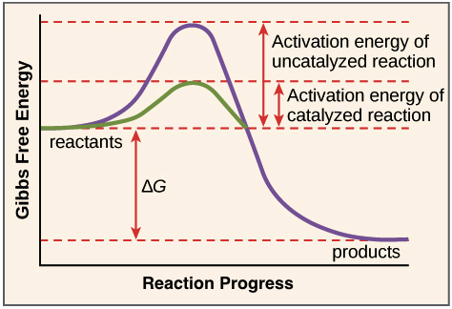
Activation energy
In order for the reaction to take place, some or all of the chemical bonds in the reactants must be broken so that new bonds, those of the products, can form. To get the bonds into a state that allows them to break, the molecule must be contorted (deformed, or bent) into an unstable state called the transition state. The transition state is a high-energy state, and some amount of energy must be added in order for the molecule reach it. This amount of energy requirement is called the activation energy.

